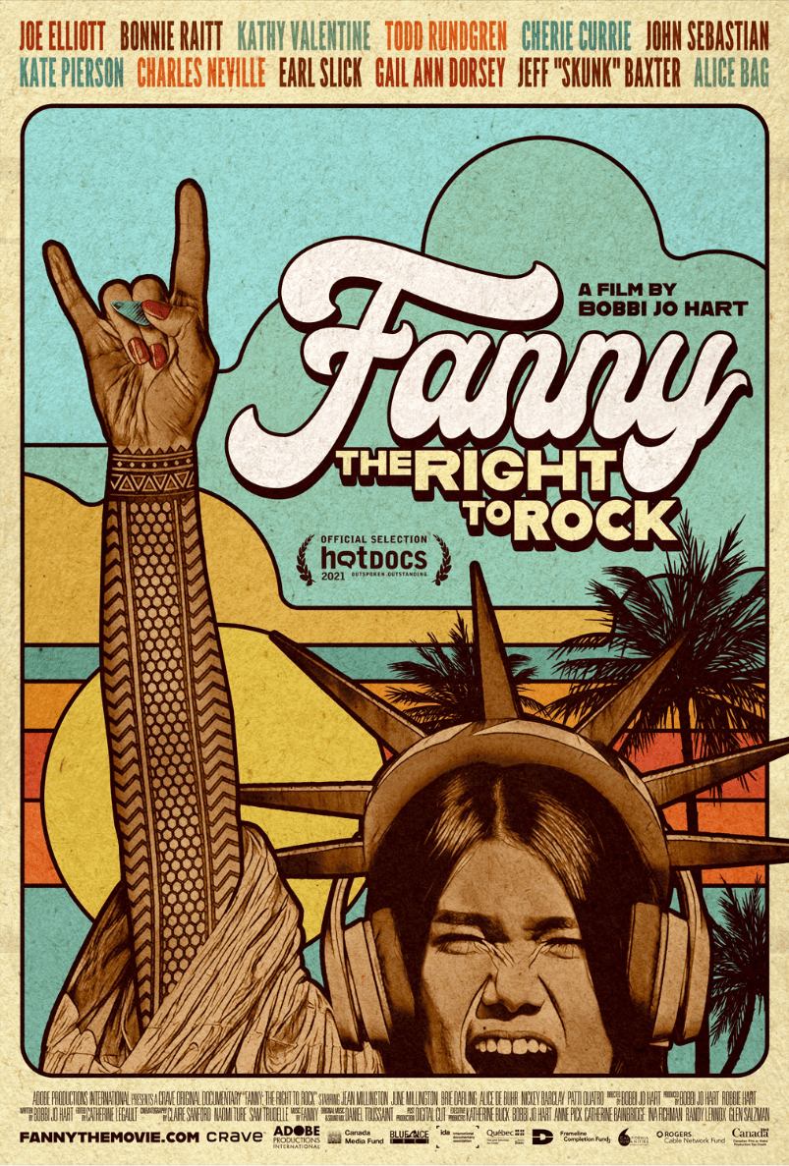
FANNY: The Right To Rock
A film by Bobbi Jo Hart
World Premiere - Hot Docs
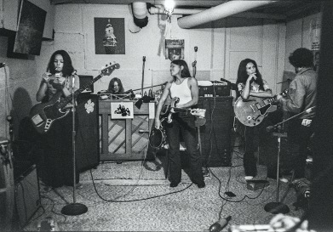
PHOTO CREDIT: Linda Wolf
“Revivify Fanny. And my work will be done.” - David Bowie
Meet one of the most important rock bands that you’ve never heard of. Their lead guitarist could shred. Their musicianship and songwriting were stellar. They were embraced by rock royalty, released five critically-acclaimed albums with Top 40 charted songs, but never broke through.
Oh, and they were women. FANNY: The Right to Rock reveals the fascinating, untold story of a phenomenal band that almost became the “female Beatles.”
The film juxtaposes a backstory rich with rare archives about a self-founded garage band of Filipina-American teens from 1960s Sacramento that morphed into the ferocious rock group Fanny. They were the first “all-girl” band to release an album with a major record label (Warner/Reprise,1970), with both straight and (silently) gay band members. The latter had to hide their lesbian identity or leave the band.
Fanny counted David Bowie as one of their most vocal fans. But factoring against their massive talent was a perfect storm of sexism, homophobia, and anti-immigrant sentiment.
And, as we hear them quip in Bobbi Jo Hart’s revelatory and moving documentary FANNY: The Right to Rock, 50 years later, their new enemy is ageism.
Fanny: The Right to Rock opens with the words of David Bowie, bemoaning the band’s fate: “One of the most important bands in American rock has been buried without a trace.”
The film then takes us deep into the woods of Goshen, Massachusetts, where we discover the Institute for the Musical Arts. It’s an underground music camp and recording studio for girls and women only, where Fanny lead guitarist June Millington, 69, has been teaching young girls to rock out long before rock camps became “a thing.”
There, she and fellow Filipina-American bandmates, including her bass-playing sister Jean and drummer Brie Darling, celebrate their 50-year reunion with a new rock record deal -- cheekily titled Fanny Walked the Earth. If the stars align, it’s a chance to right the wrongs of music history.
Fanny: The Right to Rock juxtaposes an intimate, cinema verité journey of Fanny’s uphill battle to complete and release their new album, with the fascinating herstory of the band’s improbable journey during their 70s heyday. Their controversial, self-penned lyrics dared embrace the newfound freedom of birth control as well as the trauma of the Vietnam War.
Discovered early on by the secretary of legendary producer Richard Perry and signed as teenagers to the epic Warner/Reprise label, Fanny honed their signature sound in edgy L.A. clubs like The Troubadour. Their “sorority with amps”, otherwise known as their legendary, rented Hollywood Hills band home affectionately dubbed Fanny Hill, hosted regular jam sessions with visitors/crashers including Joe Cocker, Little Feat, and Bob Dylan’s The Band. There, serious rock & roll comingled with sex, drugs and skinny dipping.
Fanny toured extensively across North America and Europe with major groups including SLADE, CHICAGO and Ike & Tina Turner. They toured while writing, recording and releasing a new album every year from 1970 -75. They performed live and gave interviews on major network TV shows with Dick Cavett, Sonny & Cher, Helen Reddy and The Tonight Show, as well as the famed BBC show “The Old Grey Whistle Test”.
But the grind -- exacerbated by countless audience slurs like, “Get yer tits out,” and journalists whose most probing question was, “How does it feel to be a woman playing an instrument?” -- eventually took its toll. Money was scarce, since Fanny innocently signed over power of attorney to the record label, who eventually forced the band to trade in their signature, bell bottomed jeans for sequined, sexy attire.
The constant pressure, inner band struggles and failure to get that #1 hit may have thwarted their journey to stardom in an era when the media and general public were not ready to embrace women as rock stars. But, as we discover in FANNY: The Right to Rock, the band’s influence on female performers who followed their groundbreaking legacy was epic.
The movie includes testimonials from Kate Pierson of the B-52s, Bonnie Raitt, Cherie Currie of The Runaways, Kathy Valentine of the Go-Gos, and Bowie bassist Gail Ann Dorsey. Male music icons also sing their praises including Todd Rundgren, Charles Neville of The Neville Brothers, The Lovin’ Spoonful’s John Sebastian and Def Leppard’s Joe Elliott (who unveils a Fanny flexi-disc he has saved for 50 years, since he discovered the band at age 12).
Will Fanny finish their new rock album and release it to finally obtain the fame and fortune they deserve? The bandmates face many new challenges along the way, but their friendship and commitment to each other reveals a resilience that lead guitarist June Millington describes best in the film, “Rock is a metaphor. When you fall down, you pick yourself back up again.”
“As Fanny drummer Alice de Buhr says in the film, ‘The conversation about a woman’s place is smack dab in the middle of rock & roll’, says director Bobbi Jo Hart. “Yet why do women still make up only 8% of Rock & Roll Hall of Fame inductees?
“And how many female rock bands do you hear on the radio today? They are out there, and I hope this film helps shake things up so that music festivals, record labels, the public and yes, even the hallowed Rock & Roll Hall of Fame, make bolder choices. Women, like Fanny, have earned the right to rock, and deserve to be properly recognized for their talent and contributions.”
“History is written by the victors,” says Hart. “So feisty women -- especially women of colour and those in the LBGTQ community -- must take the reins to help rewrite the history that has excluded them. My 25-year filmmaking career has been dedicated to bringing untold stories of extraordinary girls and women to the screen.
“I’d like to think David Bowie is smiling down now as we answer his call to ‘revivify Fanny’. Bowie was a feminist and I hope more men embrace the #HeForShe movement. It calls on them to support the vital voices of strong, loud women who have something important to say, and in doing so, make our world a better place.”
FANNY: The Right to Rock is an ADOBE PRODUCTIONS INTERNATIONAL production and CRAVE Original Documentary, produced in collaboration with Bell Media; with the financial participation of Rogers Cable Network Fund, Canada Media Fund, Quebec and Canada Tax Credits, California Humanities, KINOSMITH and the FRAMELINE Completion Fund.
The film is written and directed by Bobbi Jo Hart, and co-produced by Bobbi Jo Hart and Robbie Hart. Executive producers include Katherine Buck, Bobbi Jo Hart, Anne Pick, Catherine Bainbridge, Ina Fichman, Randy Lennox and Glen Salzman. Director of Photography is Claire Sanford. Editor is Catherine Legault. Music by Fanny. Original music & sound mix by Daniel Toussaint. Online post production by Digital Cut.

BOBBI JO HART
Director/Producer/Writer
FANNY: The Right to Rock

Biography
Bobbi Jo Hart is an award winning American/Canadian documentary filmmaker with Adobe Productions International, based in Montreal, Canada. With a career that has spanned 25 years, Hart has filmed in countries as diverse as Pakistan, Russia, Guatemala, Australia, Scotland and Zimbabwe — with subjects ranging from women’s professional soccer and tennis to classical music, comedy, dance and manic depression. Her documentary films have the most common thread of revealing untold stories of marginalized girls and women, weaving universal threads of dreams, family, love, loss, happiness, sadness, success, failure and determination. Her intimate, cinema verité style results in thought-provoking films that ultimately celebrate our shared humanity.

Her most recent feature documentary I AM NOT A ROCK STAR premiered at dozens of worldwide film festivals and was broadcast on networks in many countries, including BBCFour, SVT Sweden, ABC Australia, Documentary Channel. Music in the film included Jack Johnson & Patrick Watson. This film won many festival awards as well. Hart’s previous award winning films include SHE GOT GAME: Behind-the-Scenes of the Women's Tennis Tour (LIFE Network, Starz), which had exclusive access during over a year on tour. Hart is currently starting the festival tour for her exclusive theatrical documentary celebrating Les Ballets Trockadero de Monte Carlo (Documentary Channel, ARTV).

Recent Awards (I AM NOT A ROCK STAR):
Winner, Best Performing Arts Documentary, Canadian Screen Awards, 2014
Winner, Best Editing, Canadian Screen Awards, 2014
Nomination, Best Performing Arts Documentary, Prix Gemeaux, 2014
Nomination, Best Direction, Canadian Screen Awards, 2014

Filmography
FANNY: The Right to Rock (2021)
REBELS ON POINTE (2017)
RISE (2015)
I AM NOT A ROCK STAR (2012)
SHE GOT GAME: Behind-the-Scenes of the Women's Pro Tennis Tour (2003)
SHRINKAGE (2001)
A CALLING TO CARE (1997)

Media accolades:
"Entertaining diva antics" - VARIETY
"Engrossing..." - The National Post
"A fascinating portrait" - La Presse
"A must see" - Sports Illustrated
"Hart attains such graceful intimacy." - Basil Tsiokos, Sundance

